Title of Your Extended Abstract (TNR, capitalize each word, Bold 13pt, centered)
A. Author 1^{1*}, and A. Author 2² (TNR 11pt centered)

Institution 1
Institution 2(TNR 9pt centered)

Abstract (headlines: TNR, Bold, 12pt)

In conjunction with the IRCFOT-2023 theme, abstracts of relevant topics within the conference tracks are invited and with the peer review, considered numbers of research will be selected for the oral and poster presentations and all selected extended abstracts will be published in our IRCFOT and Eastern University, Sri Lanka Website as an eBook. Authors are requested to submit an extended abstract not exceeding two (03) pages in English. The extended abstract must include the title, author(s), introduction, material and methods, results and discussion, conclusion, and references. All illustrations must be prepared inside of the main text. Abstract should be less than or equal to 250 words.

Keywords: January, February, March, April, May (TNR 12pt, maximum of five key words)

Introduction (headlines: TNR, Bold, 12pt)

Introduction of your research with maximum of 100 words.

Materials And Methods (headlines: TNR, Bold, 12pt)

The methodology must be clearly stated and described in sufficient detail or with sufficient references.

Results And Discussion (headlines: TNR Bold, 12pt)

The findings and arguments/discussion of the work should be explicitly described and illustrated. Supporting figures, tables and images of the work. All the tables, images and figures should be centered. Figures and images should be numbered and figure headers should be placed under the figure or image; as for the tables, they should also be numbered and the table header should be placed at the top. References (if any) of the tables, figures and images should be presented right under in the form of author surname and publication date.

Conclusion (headlines: TNR Bold, 12pt)

Conclusions should include (1) the principles and generalizations inferred from the results, (2) any exceptions to, or problems with these principles and generalizations, (3) theoretical and/or practical implications of the work, and (5) conclusions drawn and recommendations.

Acknowledgment (headlines: TNR Bold, 12pt)

The authors would like to express appreciation for the support of the sponsors note that the heading of the Acknowledgments section and the References section must not be numbered.
(wishes to acknowledge Environmental protection agency and other contributors for the support)

References (headlines: TNR Bold, 12pt)

References should be cited in your extended abstract using Harvard Style of reference, and should be arranged in alphabetical order
For more information: https://libguides.scu.edu.au/harvard/journals/magazine/newspaper-articles

Example:

For books: Darwin, A & Palmer, E 2009, 'Mentoring circles in higher education', Higher Education Research and Development, vol. 28, no. 2, pp. 125-136, publisher

For Journals: Maier, H, Baron, J & McLaughlin, R 2007, 'Using online role playing simulations for teaching sustainability principles to engineering students', International Journal of Engineering Education, vol. 23, no. 6, pp. 1162-1171.

In the text, references should be cited with the name of the author(s) with the year of publication in parenthesis, e.g., (Darwin & Palmer 2009), (Maier, Baron & McLaughlin 2007), and for journal with four or more articles, (Grosso et al. 2017).

COMMON COMPONENTS TO CONSIDER

Equations

Equations should be centered and numbered consecutively, as in Eq. [1]. An alternative method is given in Eq. [2] for long sets of equations where only one referencing equation number is wanted.

 | 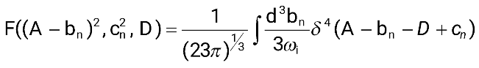 | [1]
where,

 | 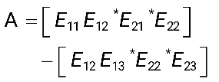 | [2]

List

Lists can be provided using numbers
- List item 1 like this;
- List item 2 is an example of a longer list item that wraps to a second line, where the second line is indented

Tables and figures

One figure and one table can be included (need a special request for the consideration of more tables and figures) in your extended abstract. Figures and tables must be centered in the column. Large figures and tables may span across both columns. Graphics may be full color. All colors will be retained on the PDF. Graphics must not use stipple fill patterns because they may not be reproduced properly. Please use only SOLID FILL colors which contrast well both on screen and on a black-and-white hardcopy, as shown in Fig. 1.

Tables should be designed to have a uniform style throughout the paper, following the style shown in Table 1. Table captions should be in 10pt “Time News Roman” bold, centered, and the texts in Table should be set in 9pt “Time News Roman” font.

Table 1. Caption heading for a table should be placed at the top of the table and within table width.
(Use “time news roman” font, size 10pt, No spacing after table title)
 | A | B | C | D
A | Aa | Ab | Ac | Ad
B | Ba | Bb | Bc | Bd
C | Ca | Cb | Cc | Cd
D | Da | Db | Dc | Dd
E | Ea | Eb | Ec | Ed

Authors are advised to prepare their figures in either black and white or color. Please prepare the figures in high resolution (>300 dpi) for half-tone illustrations or images. Pictures must be sharp enough otherwise they will be rejected. Figures must be originals, computer-generated or drafted, and placed within the text area where they are discussed. Figure 1 shows one example. Figure captions should be in 10pt “Time News Roman” font, bold, centered. When applicable, the texts inside graphs, illustrations or images should be set in 8pt “Time News Roman” font.
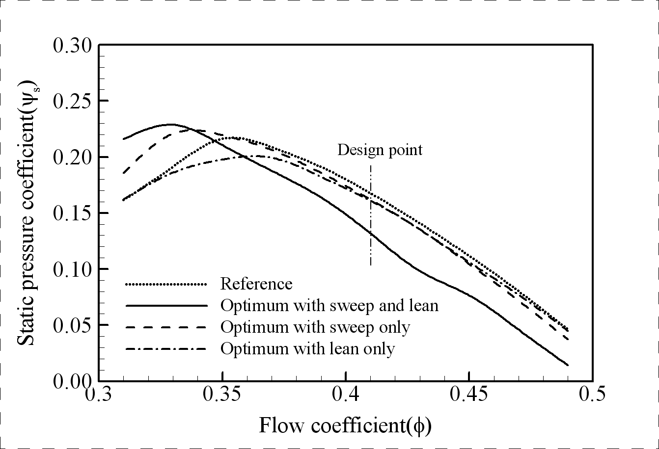
Figure 1. The caption heading for a figure should be placed below the figure and within figure/illustration width. (Use “Time News Roman” font, size 10pt, no spacing between title and figure)

Units

Use SI (MKS) as primary units or CGS units may be used as secondary units (in parentheses). Avoid combining SI and CGS units. This often leads to confusion because equations do not balance dimensionally. If you must use mixed units, clearly state the units for each quantity that you use in an equation. Do not mix complete spellings and abbreviations of units. Spell out units when they appear in text.

Note: Selected papers will be published in the Journal of FoT.

End.

